# Customizing an “emergency banner” in Primo

Prerequisites: the ability to customize your institution’s Primo view template through Primo Back Office. Not covered here. This documentation assumes that you’re familiar with this process.

The two files that are customized are:

1. In the **css** subfolder for the view 🡪 **custom1.css**
2. In the **js** subfolder for the view 🡪 **custom.js**

Contents

Customizing an “emergency banner” in Primo 1

FYI: How we originally put in the covid19 banner (**CSS only** to create & styling the message, but no html / linking possible): 1

The code for instead adding a banner component with a chunk of html within it (so it can be hyperlinked, for example) - so other institutions can replicate in their views: 3

1. custom.js to create the banner component 3

2. custom1.css to style the banner component 9

References 10

## FYI: How we originally put in the covid19 banner (**CSS only** to create & styling the message, but no html / linking possible):

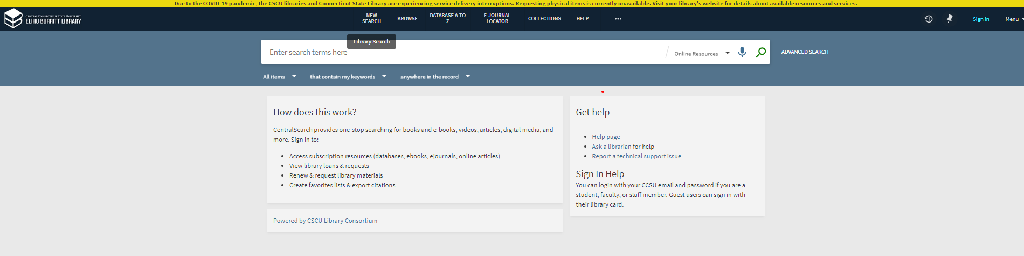

Lines 3-12 in custom1.css were initially added for that banner as follows:

/* Consortium-wide CSS customizations */

/* Emergency Banner at the very top. MGH 3/19/2020 */

primo-explore::before {

content: "Due to the COVID-19 pandemic, the CSCU libraries and Connecticut State Library are experiencing service delivery interruptions. Requesting physical items is currently unavailable. Visit your library's website for details about available resources and services.";

display: inline-block;

background: #ecd90f;

text-align: center;

padding: 2px 12px 0 12px;

width: 100%;

font-weight: bold;

}

Notes on original custom1.css-based banner:

If you change to using the new banner code via the javascript, you can probably remove - or at least comment out via the /* */ css commenting protocol (reference: <https://www.w3schools.com/css/css_comments.asp>)   
this whole section of the **custom1.css** file:

primo-explore::before {

content: "Due to the COVID-19 pandemic, the CSCU libraries and Connecticut State Library are experiencing service delivery interruptions. Requesting physical items is currently unavailable. Visit your library's website for details about available resources and services.";

display: inline-block;

background: #ecd90f;

text-align: center;

padding: 2px 12px 0 12px;

width: 100%;

font-weight: bold;

}

## The code for instead adding a banner component with a chunk of html within it (so it can be hyperlinked, for example) - so other institutions can replicate in their views:

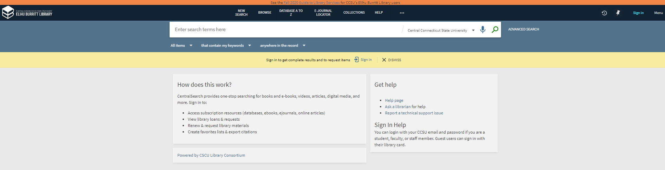

### custom.js to create the banner component

The new code that adds the banner section begins (within the entire custom.js file is down toward bottom, but above the Google Analytics section). The code segment is shown below & then also shown context of the entire custom.js file (on page 8) in this document. There are 2 segments to the code – the top one creates the code segment that will be displayed and the bottom one positions it within the Primo template, basically, I believe. NOTE the difference in the characters **`** and ' in the code – they matter.

**Lines 140-148 of code in my custom.js:**

/* MY CCSU SECTION - BANNER */

app.component('ccsuBannerComponent', {

template: `<div style="width:100%; margin: auto; text-align: center;">See the <a href="https://libguides.ccsu.edu/fall2020">Fall 2020 Guide to Library Services</a> for CCSU's Elihu Burritt Library users</div>`

})

app.component('prmTopBarBefore', {

bindings: {parentCtrl: `<`},

template: `<ccsu-banner-component></ccsu-banner-component>`

})

/* END MY CCSU SECTION - BANNER */

(function () {

"use strict";

'use strict';

var app = angular.module('viewCustom', ['angularLoad']);

/****************************************************************************************************/

/*In case of CENTRAL_PACKAGE - comment out the below line to replace the other module definition*/

/*var app = angular.module('centralCustom', ['angularLoad']);*/

/****************************************************************************************************/

/* Increase the number of Results fetched per request from 10 to 20. Modified per MH, to fix auto-scroll paging issue 021919 - SBC. */

app.config(function() {

var funky_threshold_key = 'FE UI '.concat('\u2013',' Scrolling Threshold'); /* Cannot embed high-ASCII in source-code, so use Javascript Unicode notation instead. */

appConfig['system-configuration'][funky_threshold_key] = 20; /* Change the navigation page-size. */

});

app.component('prmExploreMainAfter', {

template: '<div id="customCSCU-ExploreMainAfter"></div><prm-explore-main-after-after parent-ctrl="$ctrl.parentCtrl"></prm-explore-main-after-after>',

bindings: {parentCtrl: '<'},

controller: 'customCSCU_prmExploreMainAfter'

});

app.controller('customCSCU_prmExploreMainAfter', [function() {

var vm = this;

vm.parentCtrl.searchService.searchStateService.resultsBulkSize = 20;

}]);

/* End of Increase the number of Results fetched. */

/* Alter the Primo Browse page, Matthew Hull, December 2018 */

app.controller('customCSCU_prmCustomBrowseLinkCtrl', ['$scope', function($scope) {

var vm = this;

var browseTargetText = vm.text;

var currentParams = vm.parentCtrl.$state.params;

var currentPage = vm.parentCtrl.$state.current.name || 'exploreMain.browseSearch';

// console.dir(vm.parentCtrl);

vm.havePrefCpy = vm.parentCtrl.havePref;

vm.browseMoreURL = '';

vm.hovertext = 'Browse on "' + browseTargetText + '"';

// vm.linktext = 'More items with this ' + currentParams.browseScope;

vm.linktext = browseTargetText;

// vm.browseMoreURL = "/primo-explore/browse?vid=TCC_V1&browseScope=subject&fn=BrowseSearch&browseQuery=" + encodeURIComponent(browseTargetText);

var browseObj = {};

browseObj.vid = currentParams.vid;

browseObj.browseScope = currentParams.browseScope;

browseObj.innerPnxIndex = -1;

browseObj.browseFirstTerm = '';

browseObj.fn = 'BrowseSearch';

browseObj.browseQuery = browseTargetText;

vm.browseMoreURL = currentPage + '(' + JSON.stringify(browseObj) + ')';

}]);

app.component('prmCustomBrowseLink', {

bindings: {

parentCtrl: '<',

text: '<'

},

controller: 'customCSCU_prmCustomBrowseLinkCtrl',

template: '<div class="customCSCU browse-more-link" ng-if="$ctrl.havePrefCpy">' +

' <a ui-sref="{{$ctrl.browseMoreURL}}" title="{{$ctrl.hovertext}}" class="customCSCU arrow-link">{{$ctrl.linktext}}' +

' <prm-icon icon-type=svg svg-icon-set=primo-ui icon-definition=chevron-right link-arrow></prm-icon>' +

' </a>' +

'</div>' +

'<prm-custom-browse-link-after parent-ctrl="$ctrl"></prm-custom-browse-link-after>'

});

/* Alter the template cache to augment the <prm-browse-result> component. (We add our <prm-custom-browse-link> therein.) */

app.run(['$templateCache', function ($templateCache) {

var templatesCopy = Object.assign({}, $templateCache);

// console.dir(templatesCopy);

var browseResultComponent = 'components/search/browse/browseResult/browse-result.html';

var browseResultTemplate = $templateCache.get(browseResultComponent);

// console.dir(browseResultTemplate);

if (browseResultTemplate) {

/* Replace the existing non-preferred-term anchor <a> with our custom element. */

var my_re = /<a ng-if="\$ctrl.havePref".*?<\/a>/ig;

var newTemplate = browseResultTemplate.replace(my_re,'<prm-custom-browse-link parent-ctrl="$ctrl" text="title" ng-if="$ctrl.havePref"></prm-custom-browse-link>');

/* Replace the span-comma-span with a <br> break. (very brittle, I know.) */

my_re = /<span ng-if="\!\$first">,<\/span>/ig;

newTemplate = newTemplate.replace(my_re,'<br class="customCSCU" ng-if="!$first">');

/* Add a break (<br>) before the word See: (very brittle, I know.) */

my_re = /(<span ng-if="\$ctrl.havePref" translate="nui\.browse\.crossref\.see"><\/span>)/i;

newTemplate = newTemplate.replace(my_re,'<br class="customCSCU" ng-if="$ctrl.havePref"/>$1');

$templateCache.put(browseResultComponent, newTemplate);

/* Update the browse-result template with our modified version. */

}

}]);

/* End of Primo Browse page alteration. */

/* Add a hyperlink for a Consortium-wide search */

app.component('prmSearchResultListAfter', {

template: '<div class="customCSCU spotlight-element margin-top-large layout-row" layout="row" id="customCSCU-consortium-search-card" ng-if="$ctrl.cscu_do_display()" ng-hide="$ctrl.parentCtrl.searchInProgress">' +

' <a href="{{$ctrl.cscu_consortium_search_href}}" alt title="{{$ctrl.cscu_hovertext}}">' +

' <div class="spotlight-image"><img alt src="custom/CENTRAL_PACKAGE/img/custom_icon_hierarchy.png"></div></a>' +

' <div class="spotlight-body customCSCU"><h3 class="spotlight-title">' +

' <a class="arrow-link bold-text md-primoExplore-theme" tabindex="0" href="{{$ctrl.cscu_consortium_search_href}}" title="{{$ctrl.cscu_hovertext}}"><span>{{$ctrl.cscu_link_text}}</span>' +

' <prm-icon link-arrow="" icon-type="svg" svg-icon-set="primo-ui" icon-definition="chevron-right"><md-icon md-svg-icon="primo-ui:chevron-right" alt="" class="md-primoExplore-theme" aria-hidden="true"><svg id="chevron-right" width="100%" height="100%" viewBox="0 0 24 24" y="384" xmlns="http://www.w3.org/2000/svg" fit="" preserveAspectRatio="xMidYMid meet" focusable="false"><path d="M8.59,16.58L13.17,12L8.59,7.41L10,6L16,12L10,18L8.59,16.58Z"></path>' +

' </svg></md-icon><prm-icon-after parent-ctrl="$ctrl"></prm-icon-after></prm-icon>' +

' </a></h3><p>{{$ctrl.cscu_long_description}}</p>' +

'</div></div>' +

'<div id="customCSCU-consortium-search-card-bottom-spacer"></div>',

bindings: {parentCtrl: '<'},

controller: 'customCSCU_prmSearchResultListAfter'

});

app.controller('customCSCU_prmSearchResultListAfter', ['$timeout', function($timeout) {

var vm = this;

var stParams = vm.parentCtrl.$stateParams;

vm.cscu_link_text = 'Search all CSCU libraries';

vm.cscu_hovertext = 'Perform this search across all CSCU libraries, plus the CT State Library';

vm.cscu_long_description = 'Expand your search to include materials available all Connecticut Community College and State University libraries plus the State Library.';

vm.cscu_consortium_search_href = 'search?query=' + stParams.query +

'&tab=' + stParams.tab + '&vid=' + stParams.vid + '&search_scope=CSCU';

//vm.cscu_results = function() {

// return vm.parentCtrl.totalItems;

//}

vm.cscu_do_display = function() {

var stateParams = vm.parentCtrl.$stateParams;

if ( (stateParams.search_scope != 'CSCU') // Not already in the Consortium scope

&& (stateParams.query)

&& (stateParams.tab == 'default_tab') // Avoid the Browse/Journal search

) {

return true;

}

return false;

}

}]);

/* MY CCSU SECTION - BANNER */

app.component('ccsuBannerComponent', {

template: `<div style="width:100%; margin: auto; text-align: center;">See the <a href="https://libguides.ccsu.edu/fall2020">Fall 2020 Guide to Library Services</a> for CCSU's Elihu Burritt Library users</div>`

})

app.component('prmTopBarBefore', {

bindings: {parentCtrl: `<`},

template: `<ccsu-banner-component></ccsu-banner-component>`

})

/* END MY CCSU SECTION - BANNER */

})();

#### Notes on custom.js:

2 pieces to this, the declaration of where the component will be positioned - which is positioned below the next piece & the declaration of the content of the component which is placed first in code segment (that’s how I think of it anyway)

app.component('ccsuBannerComponent', {

template: `<div style="width:100%; margin: auto; text-align: center;">See the <a href="https://libguides.ccsu.edu/fall2020">Fall 2020 Guide to Library Services</a> for CCSU's Elihu Burritt Library users</div>`

})

app.component('prmTopBarBefore', {

bindings: {parentCtrl: `<`},

template: `<ccsu-banner-component></ccsu-banner-component>`

})

Use of the ` character (on the key that holds the tilde, often the key positioned on the keyboard below the Esc key) MATTERS vs straight single quote character

I think you may need to declare the component’s name to end with the term Component & you may need to make the component a lower-cased and hyphenated version of the name of the component - here

ccsuBannerComponent

(note camelCase) is <ccsu-banner-component>.

Probably you need both opener and closer to the component so:

<ccsu-banner-component></ccsu-banner-component>.

Insert right before the closer for the other Primo directives which looks like this:

})();

### custom1.css to style the banner component

/* Styling for the newly added component - START - SBC 08/25/20 */

**prm-topbar, prm-top-bar-before, ccsu-banner-component { background-color: #F08746; font-size:1.05em; z-index:1000; }**

/* Styling for the newly added component - END - SBC 08/25/20 */

basically, you can probably remove the **primo-explore::before** selector & styling that was used for the emergency banner and then add in the following (**assumes you named your banner component ccsu-banner-component so modify pending your component naming!**)

**prm-topbar, prm-top-bar-before, *ccsu*-banner-component {**

**background-color: #F08746;**

**font-size:1.05em;**

**z-index:1000;**

**}**

#### Notes on custom1.css: z-index for this component matters, btw!

Although the original way of adding this messaging at the top of Primo was the use of the

primo-explore::before

selector, I don’t think it would be necessary, so is commented out in this css file

# References

1. Adding an element to the Primo New UI will mean that you need to add a component using Angular, fortunately, this is not necessarily that hard if it’s a simplistic component, such as adding in a simple html segment: <https://github.com/ExLibrisGroup/primo-explore-package>
2. Follow this javascript documentation showing how to do this, including offering sample code to add a “Hello World” below the search box: <https://github.com/ExLibrisGroup/primo-explore-package/tree/master/VIEW_CODE/js>
   1. To learn how to add in your own component to the Primo New UI, I followed the information here: <https://github.com/ExLibrisGroup/primo-explore-package/tree/master/VIEW_CODE>
   2. To show the directives that you will use to insert your own component, you will need a bookmarklet / (add a javascript through the bookmark tool in your browser) that allows you to hover and view what the page segments are, what you can hook onto… the content of that javascript for the bookmarklet is at: <https://github.com/ExLibrisGroup/primo-explore-package/blob/master/VIEW_CODE/showDirectives.txt>